Wild and wondrous celebration at this year’s Wainfest

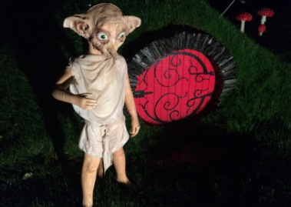
Dobby

A wild and wondrous celebration awaits the children of Donegal this October as the annual Children’s Arts and Book Festival Wainfest sets to make a return. Launching on Friday 21st September at a closed event at Inishowen Maritime Museum, the Wainfest team will reveal its vibrant 2018 programme in full.

Welcoming familiar and new partners to the festival programme this year including, Oakfield Park, Lifford Old Courthouse, An Grianan Theatre, Glenveagh National Park, Donegal Chamber Orchestra, Inishowen Development Partnership and the Balor Theatre, joint festival co-ordinators, Denis McGeady and Noelle Sandilands are delighted to see new partners come on board in 2018 with Denis stating “it really is testament to the commitment of organisations throughout the County to the children of Donegal”.

Donegal County Council’s inaugural Wainfest was held in October 1996 and since then, has grown to become a well established festival growing from strength to strength. In 2017 the festival, was shortlisted for an Excellence in Local Government Award and has once again, been shortlisted this year.

Jonathan Meres

“We are delighted to be nominated once again for Wainfest in these prestigious awards” said Denis McGeady, “This current nomination is for our 2017 programme, which saw an incredible 7,106 participants over the 8 days. Again, the hard work of the Wainfest team, participation of partner organisations and the eagerness of families and schools across the county have all helped contribute to the success of the festival. We are looking forward to revealing this year’s programme in full at the launch”.

Developed specifically for children aged 0-12, Wainfest 2018 runs from 6th to 14th October. Children all over Donegal will be able to access top quality events on their doorstep either with their school, families, or both.

Until the full festival programme is released on 21st September, here’s a taste of the high calibre events planned especially for children this October across Donegal – Muggles, an event not to be missed will be held at Oakfield Park while Dig it Kids will allow kids to enjoy an archaeological experience focusing on the recent local find of gold rings dating from the Bronze Age. Authors Steve Cole, Sarah Webb, Shane Hegarty, Tom Palmer and Jonathan Meres will join the Wainfest team delighting children all around the county and other big names including Branar, Fab Lab and Bricks4Kids will be back.

For more on what’s on during Wainfest 2018 visit www.wainfest.ie or follow Donegal County Library on Facebook or Twitter.

