18/09/19 ‘Full steam ahead’ at official launch of Wainfest 2019
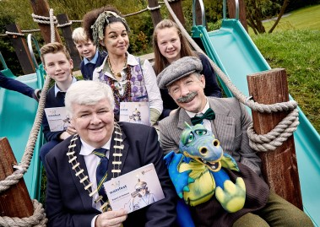
Cathaoirleach of Donegal County Council Cllr. Nicholas Crossan pictured at the official launch of Wainfest at Oakfield Park yesterday with Perrin the Elf, Professor Peartree and students from St. Eunan's N.S, Raphoe.

It was full steam ahead for Wainfest 2019 as Cathaoirleach Nicholas Crossan, along with pupils from St Eunan’s Primary School Raphoe launched this year’s programme at Oakfield Park on Tuesday (17th September).

Wainfest is Donegal’s Children’s Arts and Book Festival, which is developed each year by the energetic and inspirational team at Donegal County Council’s Culture Division. This year's festival takes place from 5 – 13 October where schools and families can "Expect to Connect" with 54 family events and 105 school events in over 30 locations over an 8-day period.

Speaking at the launch, Donna Cavanagh from Donegal Library Services explained how the festival had transformed since its inception in 1996 into “a festival which has proven its ability to engage, enlighten and involve children in high quality cultural events in their community.”

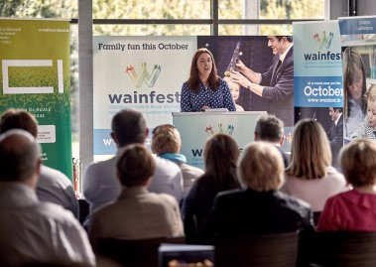
Donna Cavanagh, Senior Executive Librarian with Donegal County Council Cultural Services speaking at the official launch of Wainfest yesterday.

She added "this year we are delighted to announce a visit from best-selling children’s author, Holly Webb, who has published well over 100 books and has agreed to happily answer any questions our budding young authors might have. We have magic with award winning magician Jessica Harkin, lego animation workshops, circus skills workshops, film screenings, virtual reality in the museum, YouTube workshops, yoga, beautiful theatre productions, sensory events and a range of events for babies and toddlers.”

Launching the programme, Cathaoirleach Cllr. Nicholas Crossan commented on the wonderful opportunities for the young people of this county to connect with culture and creativity first-hand and making it an accessible and welcoming event.

"This year's festival has a range of events for children on the Autism Spectrum, in fact 20% of the programmed events are ASD Friendly this year. This has been made possible by The Dormant Accounts Fund, for libraries to support marginalized, socially excluded and disadvantaged communities, and I hope that this will become a stepping stone to the development of an ASD-Friendly Library Service in Donegal, over the coming years”.

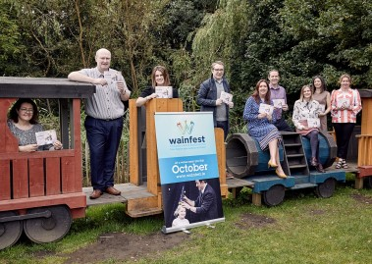
Donegal County Council Cultural Services staff pictured at the official launch of Wainfest in Oakfield Park yesterday. L-R Rita Chapman, Denis McGeady, Sinead McLaughlin, Rory Gallagher, Donna Cavanagh, Kevin McCaul, Noelle Sandilands, Aideen Tighe and Belinda Glackin.

Cllr Crossan also endorsed the partnerships which have been key to the success of Wainfest over the years saying “I am delighted to see a strong collaborative approach continue in 2019. Without partners like Eclipse and Century cinemas, Oakfield Park, Inishowen Maritime Museum and An Grianan Theatre and more we could not provide such a comprehensive programme. It is this sort of commitment, ingenuity and collaboration that emphasises the important role local authorities play as providers and enablers of culture and creativity."

Pupils from St Eunan’s Primary School, Raphoe were treated to a ride on the steam train and stories from Perrin the Elf and Professor Peartree - a taste of what to expect from Wainfest 2019.

For the second year running, Oakfield Park has partnered with Wainfest Arts and Book Festival for a special Harry Potter Experience. Taking place across two weekends (Saturday 5th & Sunday 6th and Saturday 12th & Sunday 13th October), this not-to-be-missed event for Harry Potter fans will include a host of magical and exciting events.

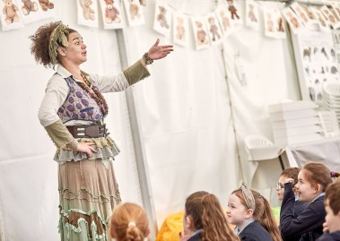
Perrin the Elf entertaining pupils from St. Eunan's N.S, Raphoe at the official launch of Wainfest yesterday.

To see all that's on offer in 2019 visit wainfest.ie or pick up a programme from your local library or Council office.

