Families, prepare yourselves for a wonderful week of children’s entertainment…

Wainfest, Donegal’s annual arts and book festival for children, is preparing to ‘blaze a trail’ across Donegal in the coming week celebrating its 25th year. With public health guidelines easing, the festival team have programmed both live and online events that are sure to inspire and set imaginations racing.

The festival begins this Saturday 2nd October with a series of exciting live family events. Our festival partners have an fabulous line-up, including toddler fun and arts and crafts in Spraoi in Carndonagh; Halloween family favourites at Eclipse Cinemas Lifford-Strabane and Bundoran; a Colmcille exhibition at Donegal County Museum; a self-guided Art Trail at Glenveagh National Park; and the Harry Potter Experience at Oakfield Park.

The live fun continues on Sunday and throughout the week with opportunities for some of the above and much more such as a screening of The Secret of Kells at Amharclann Ghaoth Dobhair; An Grianán Theatre will host an enchanting performance of A Very Old Man with Enormous Wings; a family day at Donegal Railway Heritage Centre; and water exploration with Inishowen Rivers Trust. There is lots of choice for families throughout the 10 days of the festival.

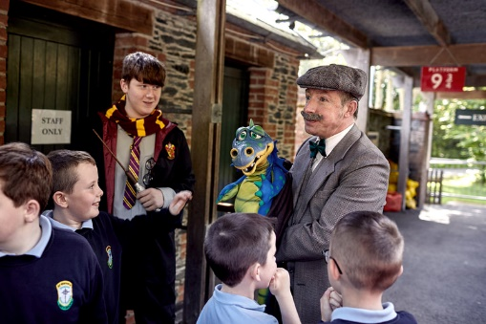

Wizards and Muggles waiting to board the Hogwarts Express at platform 93/4 at the Harry Potter Experience at Oakfield Park. Photo Credit: Paul McGuckin.

There are lots of online events programmed during the festival too, including an event with local author Louise Flanagan, a Farm Safety workshop with Agri Kids, Storytime fun with Mr Hullabaloo, an exciting twist on history with Irish History Live, stories from Perrin the Storyteller and Yoga with Tanja. There are also opportunities to meet and learn from performance poet Joshua Seigal and Donegal’s very on John D. Ruddy.

The festival committee are delighted to introduce a new element to the festival this year with an event specifically designed for parents with Dr. Malie Coyne. On Wednesday 6th she will provide hints and tips on how to show compassion and support for an anxious child.

Speaking about the festival, joint festival coordinator Denis McGeady said “We’re absolutely thrilled to provide opportunities for children’s live events this year. The pandemic threw us a curveball in 2019 and we adapted very well, but we really missed the engagement that live events provide us with. We can’t wait to see young minds buzzing and the curiosity that comes with it”.

He reassures everyone that “all events will fully comply with public health guidelines. For those who are not quite ready to venture out yet, or perhaps may be isolating at home, there are lots of opportunities for families to enjoy Wainfest online. To avoid disappointment, visit www.wainfest.ie and book your place today, as some events have sold out already”.

For more information about the festival including booking information and event times visit www.wainfest.ie or follow @DonegalCountyLibrary on Facebook and @DonegalLibrary on Twitter.
>ENDS<

