Wainfest 2018 gets off to a ‘wild and wondrous’ start

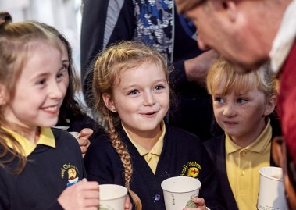

Pictured at the launch of Wainfest 2018, children of 2nd
and 3rd class from Scoil Cholmcille in Greencastle
with very special visitor in search of ‘gold’ who jumped ship
just off the coast of Greencastle when he heard a rumour
that there would be some elaborate gold chains on show
in the Inishowen Maritime Museum on Friday morning

The children of 2nd and 3rd class from Scoil Cholmcille in Greencastle were the stars at Friday’s special launch of the 2018 Wainfest Programme in the Inishowen Maritime Museum and Planetarium.

Wainfest is Donegal’s Children’s Arts and Book Festival and is developed each year by the talented and inspirational team in Donegal County Council’s Library Service. The festival takes place from 6 – 14 October and this year promises to be another ‘wild and wondrous’ adventure for the children of Donegal.

‌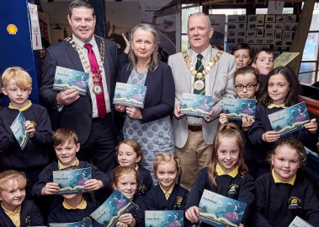

Pictured at the launch of Wainfest 2018 in the
Inishowen Maritime Museum on Friday is Cllr
Seamus O’Domhnaill, Cathaoirleach of Donegal
County Council, Eileen Burgess, Donegal County
Council, Cllr. Martin Farren, Cathaoirleach of
Inishowen MD with children from 2nd and 3rd
Class of Scoil Cholmcille, Greencastle

Speaking at the launch, Cultural Services Manager in Donegal County Council Eileen Burgess explained how the festival has developed since its first inception back in 1996 saying “Wainfest has grown beyond our own expectations. From meager beginnings in 1996, to 2018 and a festival curated especially for children with 111 schools events and 40 family events. With an investment from Donegal County Council and from the Creative Ireland Programme of just over €30,000, I am proud to say that the Division I manage has developed the festival to what it is today”.

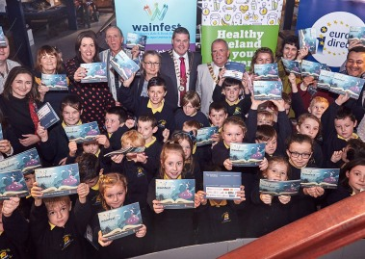

Pictured at the launch of Wainfest 2018 in the Inishowen
Maritime Museum on Friday is Cllr Seamus O’Domhnaill,
Cathaoirleach of Donegal County Council, Eileen Burgess,
Donegal County Council, Cllr. Martin Farren, Cathaoirleach
of Inishowen MD, Denise McCool, Inishowen Development
Partnership, Malachy Doyle, Guest Author with Donegal
County Library staff and children from 2nd and 3rd Class
of Scoil Cholmcille, Greencastle

“Since its inception Wainfest has proved its ability to engage, enlighten and involve children in high quality cultural events in their locality. In the last number of years we have expanded the festival to include a family programme available in the evenings and weekends so that working families can enjoy everything that Wainfest has to offer. Wainfest aims to be inclusive and accessible whether you are in Greencastle, Bundoran or Gaoth Dobhair, connecting and meeting the needs of children”.

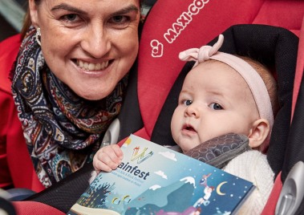

Pictured at the launch of Wainfest 2018 in the Inishowen
Maritime Museum on Friday is Sinead McLaughlin with
her beautiful daughter Ríbh

Cllr Martin Farren, Cathaoirleach of Inishowen MD talked of his delight in having the launch in the beautiful village of Greencastle on the banks of the Foyle saying “the theme of Wainfest this year is ‘Wild and Wondrous’ and what better place to launch this year’s festival than in the beautiful Inishowen Maritime Museum and Planetarium”.

He added “what better place to launch a book festival that engages children in creative activities than in the home of many great Donegal Writers. For all we know we might have the next Swan, Cary, Sweeney or Friel in this very room and maybe it could be all because they were inspired by their involvement in Wainfest”.

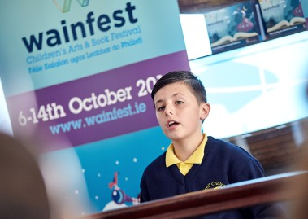

Performing MC at the launch of Wainfest 2018 in the Inishowen
Maritime Museum on Friday is Daíre Harley from Scoil Cholmcille,
Greencastle

Wainfest has grown in popularity especially in the last number of years. In 2017 audience figures increased by 104% to over 7,000 and it is expected that these audience figures will be exceeded in 2018. Cllr Seamus O’Domhnaill who officially launched this year’s programme said “I am overwhelmed by the number of events, over 150, the largest festival to date. Children across Donegal will have an opportunity to meet high profile authors, enjoy lively theatre productions, learn digital skills, be enthralled by wonderful storytellers and learn about our rivers and the sea. There is even an opportunity to board the Hogwarts express!”

Cllr O’Domhnaill also acknowledged the important role played by various partners in the development of this top class festival saying “the partnership approach of Wainfest has continued in 2018 with the inclusion of new partners Oakfield Park in Raphoe, the Balor Theatre in Ballybofey and Water Quality Improvement project, CatchmentCARE. It is with this sort of commitment, ingenuity, collaboration and sense of partnership that emphasises the important role local authorities can and do play as providers and enablers of culture and creativity”.

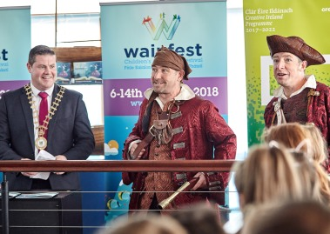

Pictured at the launch of Wainfest 2018 in the Inishowen Maritime
Museum on Friday is Cllr Seamus O’Domhnaill, Cathaoirleach
of Donegal County Council with two special visitors in
search of ‘gold’.

The Cathaoirleach had a special word of thanks for Daíre Harley and Eve Cavanagh from Scoil Cholmcille. Daíre performed the Master of Ceremonies for the launch and Eve Cavanagh recited a beautiful poem. He also thanked author Malachy Doyle for his wonderful inspirational storytelling workshop with the children of Scoil Cholmcille before the launch event.

The launch concluded with the arrival of two infamous pirates who jumped ship just off the coast of Greencastle in search of gold. Apparently rumour had it that there would be some elaborate gold chains on show in the Inishowen Maritime Museum on Friday morning. The Cathaoirleach Cllr. Seamus O’Domhnaill and Cllr. Martin Farren made a speedy exit from the building!!

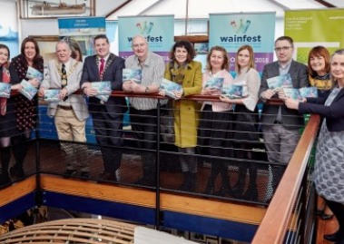

Pictured at the launch of Wainfest 2018 in the Inishowen
Maritime Museum on Friday is Donegal County Library
staff Karen Sheehy, Donna Cavanagh, Denis McGeady,
Belinda Glackin, Rory Gallagher, Frances Crampsie, Eileen
Burgess with Cllr Seamus O’Domhnaill, Cathaoirleach of
Donegal County Council, Cllr. Martin Farren, Cathaoirleach
of Inishowen MD and Denise McCool, Inishowen
Development Partnership.

For more on what’s on during Wainfest visit wainfest.ie or pick up a programme from your local library or Council office.

